Smart Grid Alarm Engine Architecture
Alarm Engine je “srce” SCADA sustava koje:
- detektira abnormalna stanja
- generira alarme
- prioritizira incidente
- šalje notifikacije
- aktivira AI i predictive maintenance workflowe
Za tvoj Digital Twin projekt alarm engine treba biti:
- realtime
- event-driven
- scalable
- AI-aware
- geo-aware

Alarm Engine Arhitektura
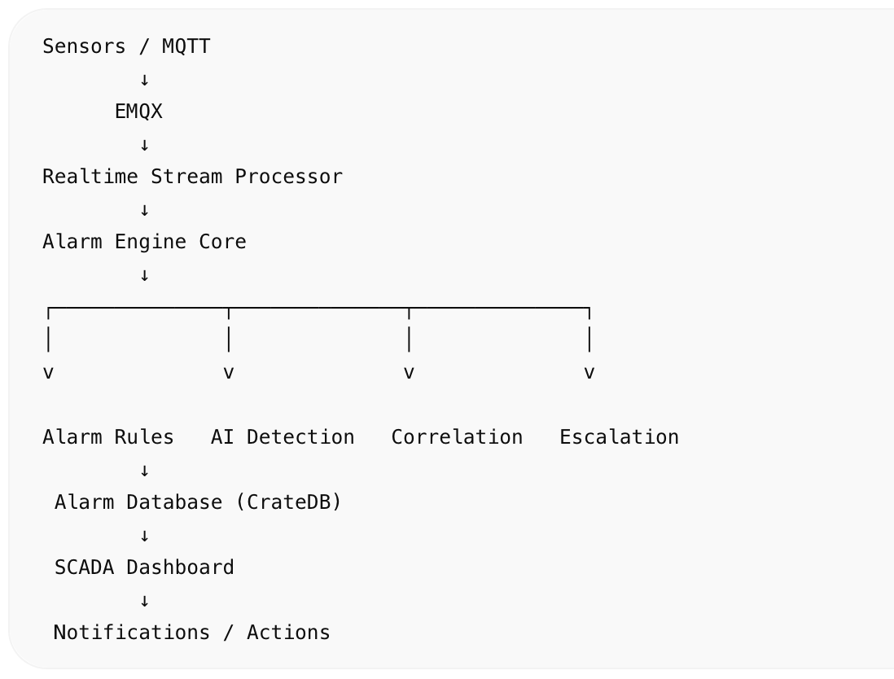

Vrste alarma

1. Electrical Alarms

Voltage
- undervoltage
- overvoltage
- voltage imbalance

Current
- overload
- phase imbalance

Frequency
- frequency instability
- grid oscillation

Harmonics
- THD critical
- power quality degradation

Thermal Alarms
- oil overheating
- winding overheating
- busbar overheating
- cooling failure

Oil & Gas Alarms
- hydrogen spike
- methane increase
- acetylene critical
- oil pressure abnormal
- humidity risk

AI Alarms

Predictive Maintenance
- transformer degradation risk
- remaining lifetime critical

Blackout Prediction
- cascade failure probability
- overload propagation

Anomaly Detection
- abnormal behavior patterns
- AI risk scoring

Alarm Severity Levels
Level | Description
INFO | Informational
WARNING | Attention required
CRITICAL | Immediate action
EMERGENCY | Grid risk / outage

Alarm Lifecycle
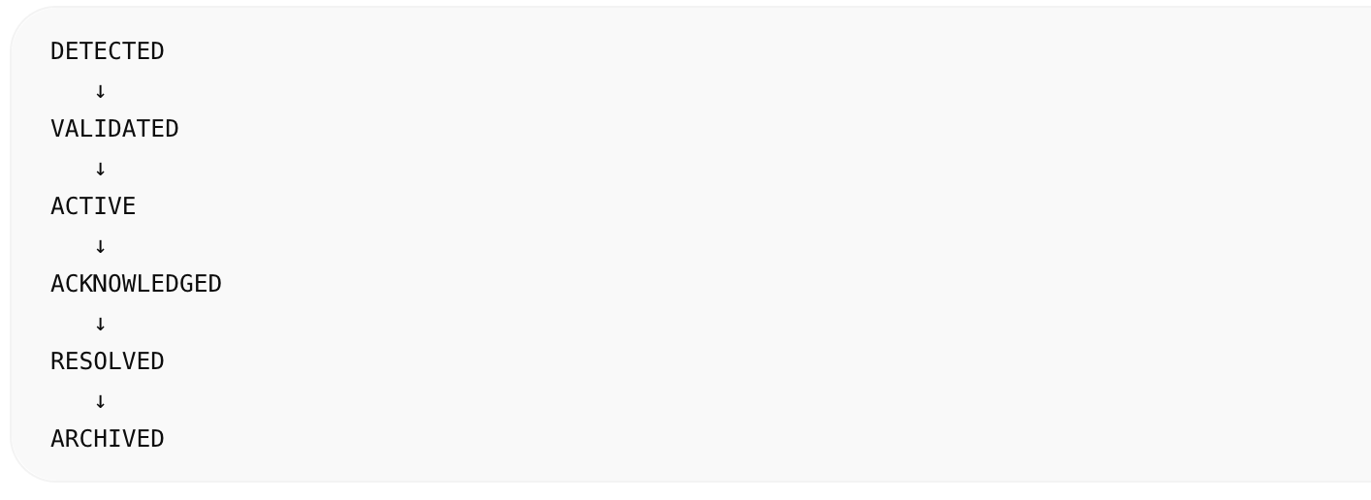

Alarm Correlation Engine
Ključ industrijskog SCADA sustava.
Umjesto:
dobiješ:

Primjer korelacije
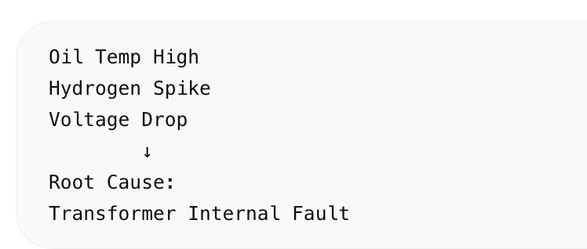

Rule Engine

Primjer pravila

Oil Temperature
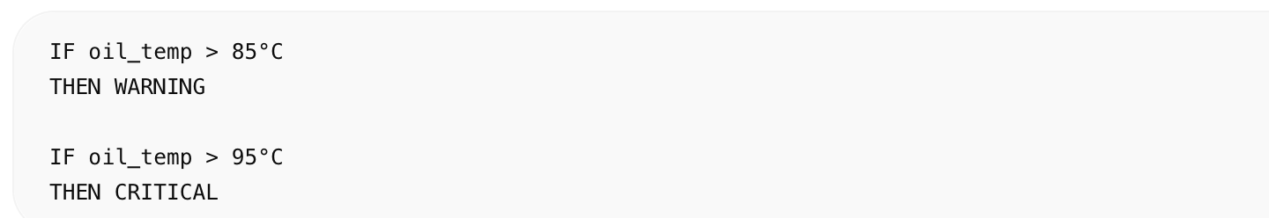

Harmonics
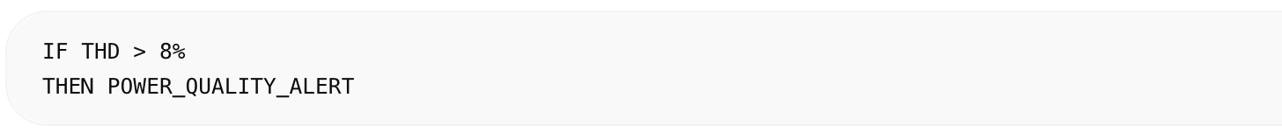

Blackout Risk
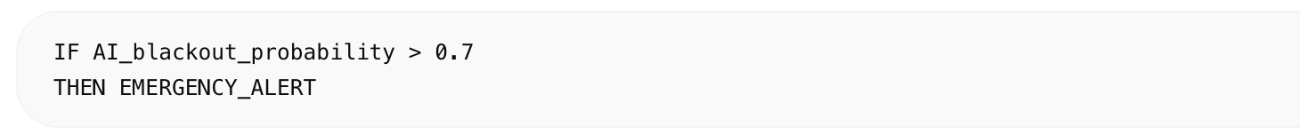

AI-Assisted Alarm Scoring
Finalni score:
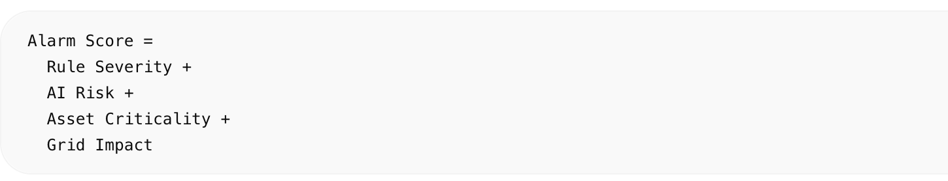

Geo Alarm Intelligence
SCADA mapa prikazuje:
- crvene trafostanice
- blackout propagation
- overload zone
- thermal hotspots

Alarm Analytics

Dashboard Features
- active alarms
- alarm trends
- MTTR
- failure statistics
- risk heatmaps
- alarm frequency

Alarm Schema (CrateDB)
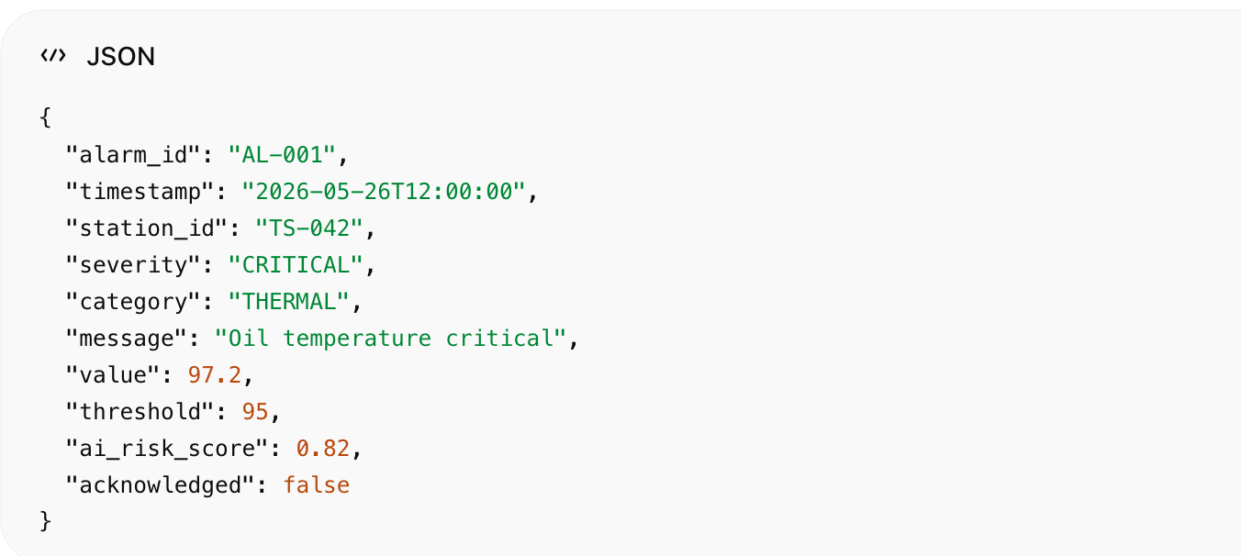
{
"alarm_id": "AL-001",
"timestamp": "2026-05-26T12:00:00",
"station_id": "TS-042",
"severity": "CRITICAL",
"category": "THERMAL",
"message": "Oil temperature critical",
"value": 97.2,
"threshold": 95,
"ai_risk_score": 0.82,
"acknowledged": false
}

Notification Engine

Channels
- SCADA popup
- WebSocket live alerts
- Email
- SMS
- Teams/Slack
- PagerDuty

Realtime Flow
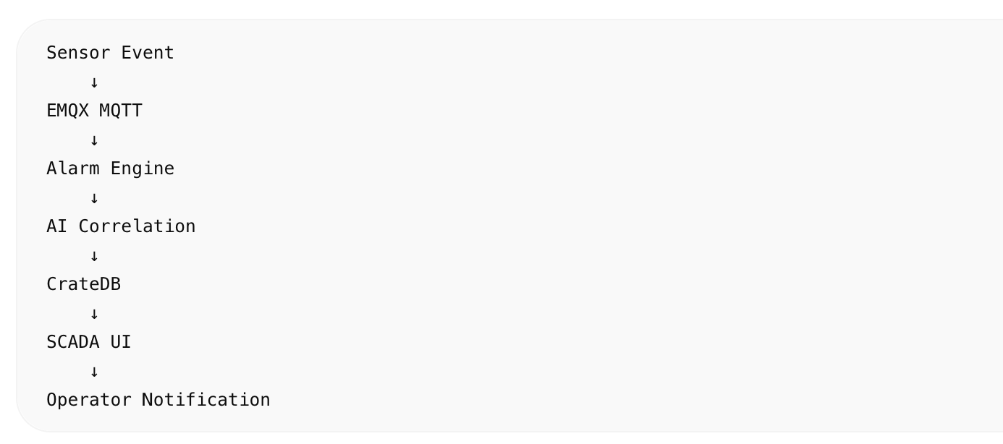

Advanced Features

Predictive Alarms
Alarm prije nego kvar nastane.

Dynamic Thresholds
Threshold ovisi o:
- loadu
- ambient temperaturi
- povijesti

Alarm Suppression
sprječava alarm flood.

Root Cause Analysis
AI pronalazi stvarni uzrok.

Enterprise Deployment

Components
Layer | Technology
Messaging | EMQX
Analytics | CrateDB
Backend | FastAPI
Frontend | Vue.js + Quasar Framework
AI | PyTorch
Stream Processing | Apache Kafka

Rezultat
Dobivaš:

Smart Grid Alarm Intelligence Platform
koja:
- detektira kvarove
- predviđa blackout
- prioritizira incidente
- smanjuje false-positive alarme
- pomaže operatorima
- integrira AI + Digital Twin + SCADA
To je već utility-grade enterprise architect

